President Jimmy Carter
Elaborated Unit Focus | In this unit, students will learn about President Jimmy Carter. Students will also learn the significance of Jimmy Carter’s life, from his beginnings as a farmer in rural Georgia to his time as the President of the United States. They will have a full understanding of how their lives in modern Georgia are similar to and different from the lives of Jimmy Carter.
Connection to  Connecting  Theme/Enduing  Understandings | They will discuss President Carter’s political and personal roles and leadership by connecting to the themes of individuals, groups, and institutions that influenced his life.  The ideas of location and time, change, and continuity will help  students explore the similarities and differences in their own lives and in the life of Jimmy Carter, as well as the changes that have occurred within the lifetime of President Carter.
GSE for Social Studies  (standards and elements) | SS2H1 Describe the lives and contributions of historical figures in Georgia history.  f. Jimmy Carter (leadership and human rights)  c. Describe how the region in which these historic figures lived affected their lives and compare these regions to the region in which students live.  SS2CG3 Give examples of how the historical figures in SS2H1 demonstrate positive citizenship traits such as: honesty, dependability, trustworthiness, honor, civility, good sportsmanship, patience, and compassion.
Connection to Literacy Standards for Social Studies (reading and/or writing) | ELAGSE2RI1: Ask and answer such questions as who, what, where, when, why, and how to demonstrate understanding of key details in a text.  ELAGSE2RI3: Describe the connection between a series of historical events, scientific ideas or concepts, or steps in technical procedures in a text.  ELAGSE2RI4: Determine the meanings of words and phrases in a text relevant to a grade 2 topic or subject area. ELAGSE2RI5: Know and use various text features (e.g., captions, bold print, subheadings, glossaries, indexes, electronic menus, icons) to locate key facts or information in a text efficiently.  ELAGSE2RI7: Explain how specific images contribute to and clarify a text.  ELAGSE2RI9: Compare and contrast the most important points presented by two texts on the same topic.  ELAGSE2W6: With guidance and support from adults, use a variety of tools to produce and publish writing, including digital tools and collaboration with peers.  ELAGSE2W7: Participate in shared research and writing projects (e.g., read a number of books on a single topic to produce a report; record science observations).  ELAGSE2W8: Recall information from experiences or gather information from provided sources to answer a question.  ELAGSE2SL1: Participate in collaborative conversations with diverse partners about grade 2 topics and texts with peers and adults in small and larger groups.  ELAGSE2SL2: Recount or describe key ideas or details from written texts read aloud or information presented orally or through other media.  ELAGSE2SL3: Ask and answer questions about what a speaker says in order to clarify comprehension, gather additional information, or deepen understanding of a topic or issue.  ELAGSE2SL4: Tell a story or recount an experience with appropriate facts and relevant, descriptive details, speaking audibly in coherent sentences.  ELAGSE2SL6: Produce complete sentences when appropriate to task and situation in order to provide requested detail or clarification. (See grade 2 Language standards 1 and 3 for specific expectations.)  ELAGSE2L1: Demonstrate command of the conventions of standard English grammar and usage when writing or speaking. ELAGSE2L2: Demonstrate command of the conventions of standard English capitalization, punctuation, and spelling when writing.  ELAGSE2L3: Use knowledge of language and its conventions when writing, speaking, reading, or listening.  ELAGSE2L2: Demonstrate command of the conventions of standard English capitalization, punctuation, and spelling when writing.  ELAGSE2L4: Determine or clarify the meaning of unknown and multiple-meaning words and phrases based on grade 2 reading and content, choosing flexibly from an array of strategies.
Connection to Social Studies Matrices (information processing and/or map and globe skills) | Map and Globe Skills: 1 (cardinal directions), 2 (intermediate directions), 3 (letter/number grid system) 7 (use maps to explain impact of geography on historical and current events)  Information Processing Skills: 1 (similarities/differences), 2 (organize items chronologically), 3 (problems/solutions) 4 (fact/opinion), 5 (main idea, details, sequence, cause/effect), 6 (primary/secondary sources), 7 (interpret timelines), 8 (social studies reference resources used for specific purposes), 9 (constructs charts and tables), 10 (analyze artifacts)
Essential Questions and Related Supporting/Guiding Questions
Enduring Understanding 1 | K-5 EU: The student will understand that what people, groups, and institutions say and do can help or harm others whether they mean to or not.  What character traits make good leaders?  a. How does Jimmy Carter show compassion for others?  c. In what ways can you be a good leader?
Enduring Understanding 2 | K-5 EU: The student will understand that where people live matters.  How does where you live affect how you live?  - What did Jimmy Carter do before he became Governor and President?  - Why do you think the Carter family had a farm?
Enduring Understanding 3 | K-5 EU: The student will understand that some things will change over time, while other things will stay the same.  How has Georgia and the U.S. changed over time?  a. How has Jimmy Carter’s work for human rights influenced Americans and the world?  - In what ways did Juliette Gordon Low’s legacy live on through the Girl Scouts?  - How is your life similar and different to the lives of Jimmy Carter and Juliette Gordon Low?
Instructional Activities and Assessments

Research Organizer
The graphic organizer is designed to be used as a resource for students to organize information about Jimmy Carter. Students can add information as they are learning and researching during this unit.
GSE Standards and Elements |  | SS2H1 Describe the lives and contributions of historical figures in Georgia history.  - Juliette Gordon Low (Girl Scouts and leadership)  - Jimmy Carter (leadership and human rights)  SS2G2 Describe the cultural and geographic systems associated with the historical figures in SS2H1 and Georgia’s Creek and  Cherokee in SS2H2.  c. Describe how the region in which these historic figures lived affected their lives and compare these regions to the region in which students live.  SS2CG3 Give examples of how the historical figures in SS2H1 demonstrate positive citizenship traits such as: honesty, dependability, trustworthiness, honor, civility, good sportsmanship, patience, and compassion.
Literacy Standards  Social Studies Matrices  Enduring Understanding(s) |  | ELAGSE2RI1: Ask and answer such questions as who, what, where, when, why, and how to demonstrate understanding of key details in a text.  ELAGSE2RI3: Describe the connection between a series of historical events, scientific ideas or concepts, or steps in technical procedures in a text.  ELAGSE2RI9: Compare and contrast the most important points presented by two texts on the same topic.  ELAGSE2W6: With guidance and support from adults, use a variety of tools to produce and publish writing, including digital tools and collaboration with peers.  ELAGSE2W7: Participate in shared research and writing projects (e.g., read a number of books on a single topic to produce a report; record science observations).  ELAGSE2W8: Recall information from experiences or gather information from provided sources to answer a question. ELAGSE2SL1: Participate in collaborative conversations with diverse partners about grade 2 topics and texts with peers and adults in small and larger groups.  ELAGSE2SL2: Recount or describe key ideas or details from written texts read aloud or information presented orally or through other media.  ELAGSE2SL3: Ask and answer questions about what a speaker says in order to clarify comprehension, gather additional information, or deepen understanding of a topic or issue.  ELAGSE2SL4: Tell a story or recount an experience with appropriate facts and relevant, descriptive details, speaking audibly in coherent sentences.  ELAGSE2SL6: Produce complete sentences when appropriate to task and situation in order to provide requested detail or  clarification. (See grade 2 Language standards 1 and 3 for specific expectations.)  ELAGSE2L1: Demonstrate command of the conventions of standard English grammar and usage when writing or speaking. ELAGSE2L2: Demonstrate command of the conventions of standard English capitalization, punctuation, and spelling when writing.  ELAGSE2L3: Use knowledge of language and its conventions when writing, speaking, reading, or listening.  Map Skills: 7 (use maps to explain impact of geography on historical and current events)  Information Processing Skills: 1 (similarities/differences), 2 (organize items chronologically), 4 (fact/opinion), 5 (main idea, details, sequence, cause/effect), 6 (primary/secondary sources), 8 (social studies reference resources used for specific purposes), 9 (constructs charts and tables), 10 (analyze artifacts)  K-5 EU: The student will understand that some things will change over time, while other things will stay the same.

Research Organizer
Name:
Important Dates | President Jimmy Carter | Contributions
Our Similarities | 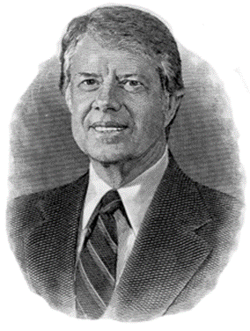 | Our Differences
Character Traits | Jobs | Important people in his life.

The Carter Family Farm
Students will study a grid map of the Carter Family Farm and answer questions using the map.
GSE Standards and Elements | SS2H1 Describe the lives and contributions of historical figures in Georgia history.  f. Jimmy Carter (leadership and human rights)  SS2G2 Describe the cultural and geographic systems associated with the historical figures in SS2H1 and Georgia’s  Creek and Cherokee in SS2H2.  c. Describe how the region in which these historic figures lived affected their lives and compare these regions to the region in which students live.
Literacy Standards  Social Studies Matrices  Enduring Understanding(s) | ELAGSE2RI1: Ask and answer such questions as who, what, where, when, why, and how to demonstrate understanding of key details in a text.  ELAGSE2RI3: Describe the connection between a series of historical events, scientific ideas or concepts, or steps in technical procedures in a text.  ELAGSE2RI5: Know and use various text features (e.g., captions, bold print, subheadings, glossaries, indexes, electronic menus, icons) to locate key facts or information in a text efficiently.  ELAGSE2RI7: Explain how specific images contribute to and clarify a text.  ELAGSE2W7: Participate in shared research and writing projects (e.g., read a number of books on a single topic to produce a report; record science observations).  ELAGSE2W8: Recall information from experiences or gather information from provided sources to answer a question.  ELAGSE2L2: Demonstrate command of the conventions of standard English capitalization, punctuation, and spelling when writing.  ELAGSE2SL2: Recount or describe key ideas or details from written texts read aloud or information presented orally or through other media.  ELAGSE2SL3: Ask and answer questions about what a speaker says in order to clarify comprehension, gather additional information, or deepen understanding of a topic or issue.  ELAGSE2SL4: Tell a story or recount an experience with appropriate facts and relevant, descriptive details, speaking  audibly in coherent sentences.  ELAGSE2SL6: Produce complete sentences when appropriate to task and situation in order to provide requested detail or clarification.  Map and Globe Skills: 1 (cardinal directions), 2 (intermediate directions), 3 (letter/number grid system) 7 (use maps to explain impact of geography on historical and current events)  Information Processing Skills: 1 (similarities/differences), 5 (main idea, details, sequence, cause/effect), 8 (social studies reference resources used for specific purposes), 10 (analyze artifacts)  K-5 EU: The student will understand that where people live matters.

Mapping the Carter Family Farm
Name:

Directions: Use the grid to answer the questions on page 2.

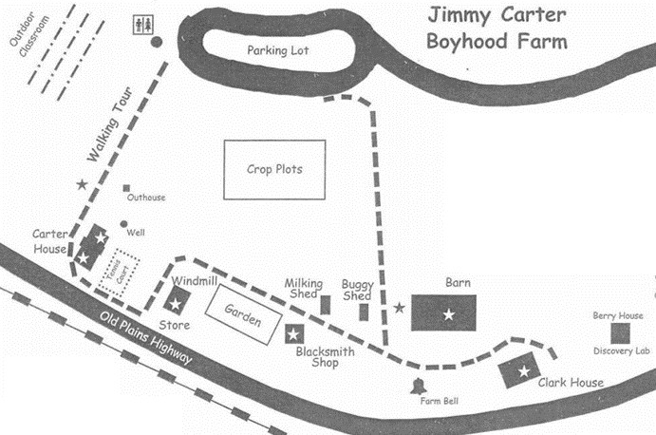


A

5
4
3
1
2
E
B
C
D

